PROGRAM 9 (CO5)

AIM: Create database using SQLite and perform insert operation.

XML

*<?***xml version="1.0" encoding="utf-8"***?>*<**LinearLayout  
 xmlns:android="http://schemas.android.com/apk/res/android"  
 xmlns:tools="http://schemas.android.com/tools"  
 android:layout_width="match_parent"  
 android:layout_height="match_parent"  
 android:orientation="vertical"  
 tools:context=".MainActivity"**>  
  
 <**EditText  
 android:id="@+id/idEdtCourseName"  
 android:layout_width="match_parent"  
 android:layout_height="wrap_content"  
 android:layout_margin="10dp"  
 android:hint="Enter course Name"** />  
  
 <**EditText  
 android:id="@+id/idEdtCourseTracks"  
 android:layout_width="match_parent"  
 android:layout_height="wrap_content"  
 android:layout_margin="10dp"  
 android:hint="Enter Course Tracks"** />

<**EditText  
 android:id="@+id/idEdtCourseDuration"  
 android:layout_width="match_parent"  
 android:layout_height="wrap_content"  
 android:layout_margin="10dp"  
 android:hint="Enter Course Duration"** />  
  
 <**EditText  
 android:id="@+id/idEdtCourseDescription"  
 android:layout_width="match_parent"  
 android:layout_height="wrap_content"  
 android:layout_margin="10dp"  
 android:hint="Enter Course Description"** /><**Button  
 android:id="@+id/idBtnAddCourse"  
 android:layout_width="match_parent"  
 android:layout_height="wrap_content"  
 android:layout_margin="10dp"  
 android:text="Add Course"  
 android:textAllCaps="false"** />  
  
</**LinearLayout**>

Java

**package** com.example.sqllite;  
  
**import** android.os.Bundle;  
**import** android.app.Activity;  
**import** android.view.Menu;  
**import** android.view.View;  
**import** android.widget.Button;  
**import** android.widget.EditText;  
**import** android.widget.Toast;  
  
**public class** MainActivity **extends** Activity {  
 **private** EditText **courseNameEdt**, **courseTracksEdt**, **courseDurationEdt**, **courseDescriptionEdt**;  
 **private** Button **addCourseBtn**;  
 **private** DBHandler **dbHandler**;  
  
 @Override  
 **protected void** onCreate(Bundle savedInstanceState) {  
 **super**.onCreate(savedInstanceState);  
 setContentView(R.layout.***activity_main***);  
 **courseNameEdt** = (EditText)findViewById(R.id.***idEdtCourseName***);  
 **courseTracksEdt** = (EditText)findViewById(R.id.***idEdtCourseTracks***);  
 **courseDurationEdt** = (EditText)findViewById(R.id.***idEdtCourseDuration***);  
 **courseDescriptionEdt** =(EditText) findViewById(R.id.***idEdtCourseDescription***);  
 **addCourseBtn** = (Button)findViewById(R.id.***idBtnAddCourse***);  
  
 **dbHandler** = **new** DBHandler(MainActivity.**this**);  
**addCourseBtn**.setOnClickListener(**new** View.OnClickListener() {  
 @Override  
 **public void** onClick(View v) {  
  
 *// below line is to get data from all edit text fields.* String courseName = **courseNameEdt**.getText().toString();  
 String courseTracks = **courseTracksEdt**.getText().toString();  
 String courseDuration = **courseDurationEdt**.getText().toString();  
 String courseDescription = **courseDescriptionEdt**.getText().toString();  
  
 **if** (courseName.isEmpty() && courseTracks.isEmpty() && courseDuration.isEmpty() && courseDescription.isEmpty()) {  
 Toast.*makeText*(MainActivity.**this**, **"Please enter all the data.."**, Toast.***LENGTH_SHORT***).show();  
 **return**;  
 }  
**dbHandler**.addNewCourse(courseName, courseDuration, courseDescription, courseTracks);  
Toast.*makeText*(MainActivity.**this**, **"Course has been added."**, Toast.***LENGTH_SHORT***).show();  
 **courseNameEdt**.setText(**""**);  
 **courseDurationEdt**.setText(**""**);  
 **courseTracksEdt**.setText(**""**);  
 **courseDescriptionEdt**.setText(**""**);  
 }  
 });  
 }  
}

**package** com.example.sqllite;  
  
  
**import** android.content.ContentValues;  
**import** android.content.Context;  
**import** android.database.sqlite.SQLiteDatabase;  
**import** android.database.sqlite.SQLiteOpenHelper;  
  
**public class** DBHandler **extends** SQLiteOpenHelper {  
  
 **private static final** String ***DB_NAME*** = **"coursedb"**;

**private static final int *DB_VERSION*** = 1;  
  
 **private static final** String ***TABLE_NAME*** = **"mycourses"**;  
**private static final** String ***ID_COL*** = **"id"**;  
  
 **private static final** String ***NAME_COL*** = **"name"**;  
  
 **private static final** String ***DURATION_COL*** = **"duration"**;  
  
 **private static final** String ***DESCRIPTION_COL*** = **"description"**;  
  
 **private static final** String ***TRACKS_COL*** = **"tracks"**;  
  
 **public** DBHandler(Context context) {  
 **super**(context, ***DB_NAME***, **null**, ***DB_VERSION***);  
 }  
  
 @Override  
 **public void** onCreate(SQLiteDatabase db) {  
String query = **"CREATE TABLE "** + ***TABLE_NAME*** + **" ("** + ***ID_COL*** + **" INTEGER PRIMARY KEY AUTOINCREMENT, "** + ***NAME_COL*** + **" TEXT,"** + ***DURATION_COL*** + **" TEXT,"** + ***DESCRIPTION_COL*** + **" TEXT,"** + ***TRACKS_COL*** + **" TEXT)"**;  
  
 db.execSQL(query);  
 }  
  
 **public void** addNewCourse(String courseName, String courseDuration, String courseDescription, String courseTracks) {  
  
 SQLiteDatabase db = **this**.getWritableDatabase();  
  
 ContentValues values = **new** ContentValues();  
  
 values.put(***NAME_COL***, courseName);  
 values.put(***DURATION_COL***, courseDuration);  
 values.put(***DESCRIPTION_COL***, courseDescription);  
 values.put(***TRACKS_COL***, courseTracks);  
  
 db.insert(***TABLE_NAME***, **null**, values);  
  
db.close();  
 }  
  
 @Override  
 **public void** onUpgrade(SQLiteDatabase db, **int** oldVersion, **int** newVersion) {  
 db.execSQL(**"DROP TABLE IF EXISTS "** + ***TABLE_NAME***);  
 onCreate(db);  
 }  
}

OUTPUT

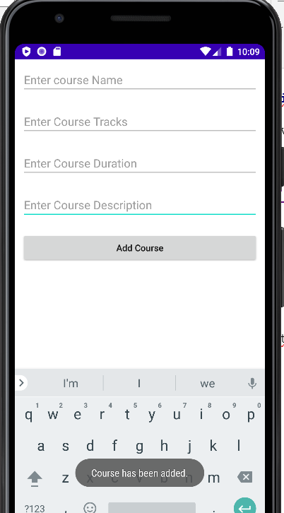

RESULT: Program to create database using SQLite and perform insert operation is successfully executed and output verified.